|  |  |  |
| --- | --- | --- |
| **INDEX** | | |
| **Sr. No.** | **Document** | **Page No.** |
| **1.** | **COPY OF EDUCATIONAL AND EXPERIANCE CERTIFICATES**   * 1. **10th Marksheet**   2. **12th Marksheet**   3. **Undergraduate Marksheet (BCCA)**   4. **Postgraduate Marksheet (MCA)**   5. **Experience Certificates** | **1**  **2**  **3 - 5**  **6 - 10**  **11** |
| **2.** | **SALARY CERTIFICATE (last 3 month)** | **12 - 14** |
| **3.** | **PASSPORT SIZE PHOTOGRAPHS** | **15** |
| **4.** | **CURRENT ADDRESS PROOF** | **16** |
| **5.** | **PERMANENT ADDRESS PROOF**  **5.1 Voter Id Card**  **5.2 Pan Card** | **17**  **18** |
| **6.** | **BANK DETAILS** | **19** |
| **7.** | **RESUME** | **20 - 21** |

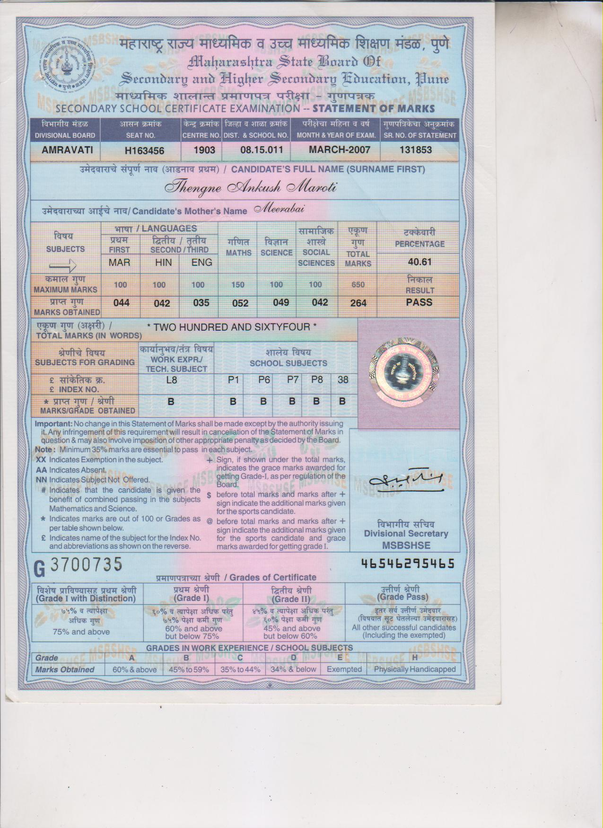

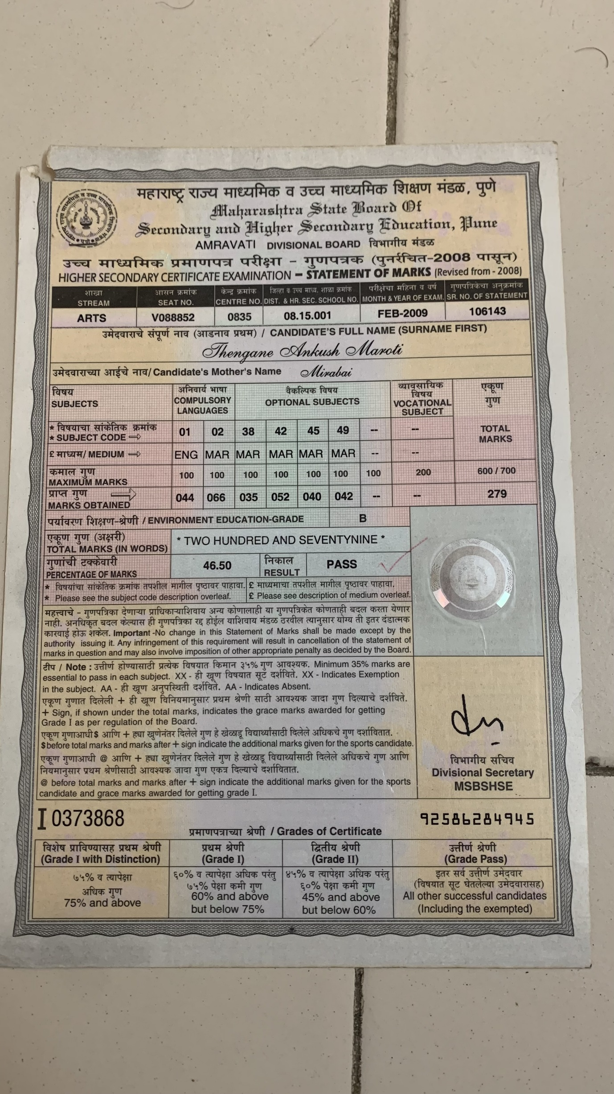

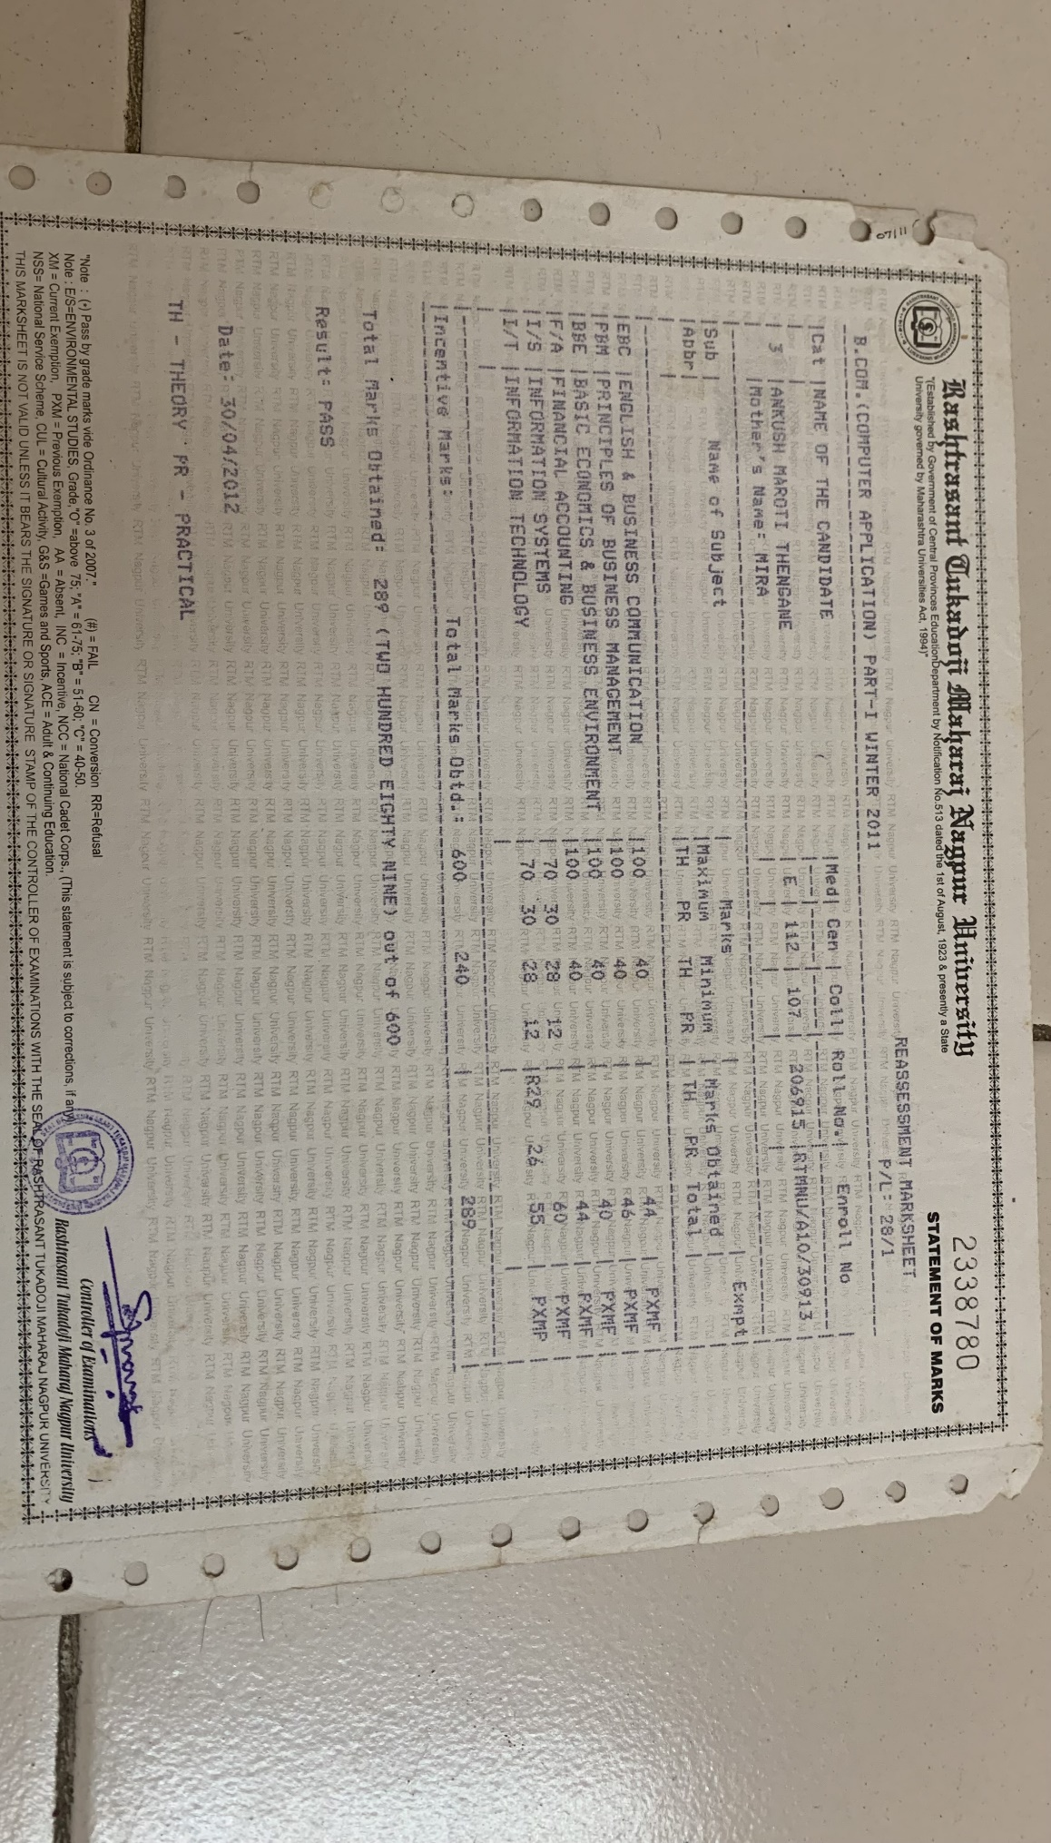

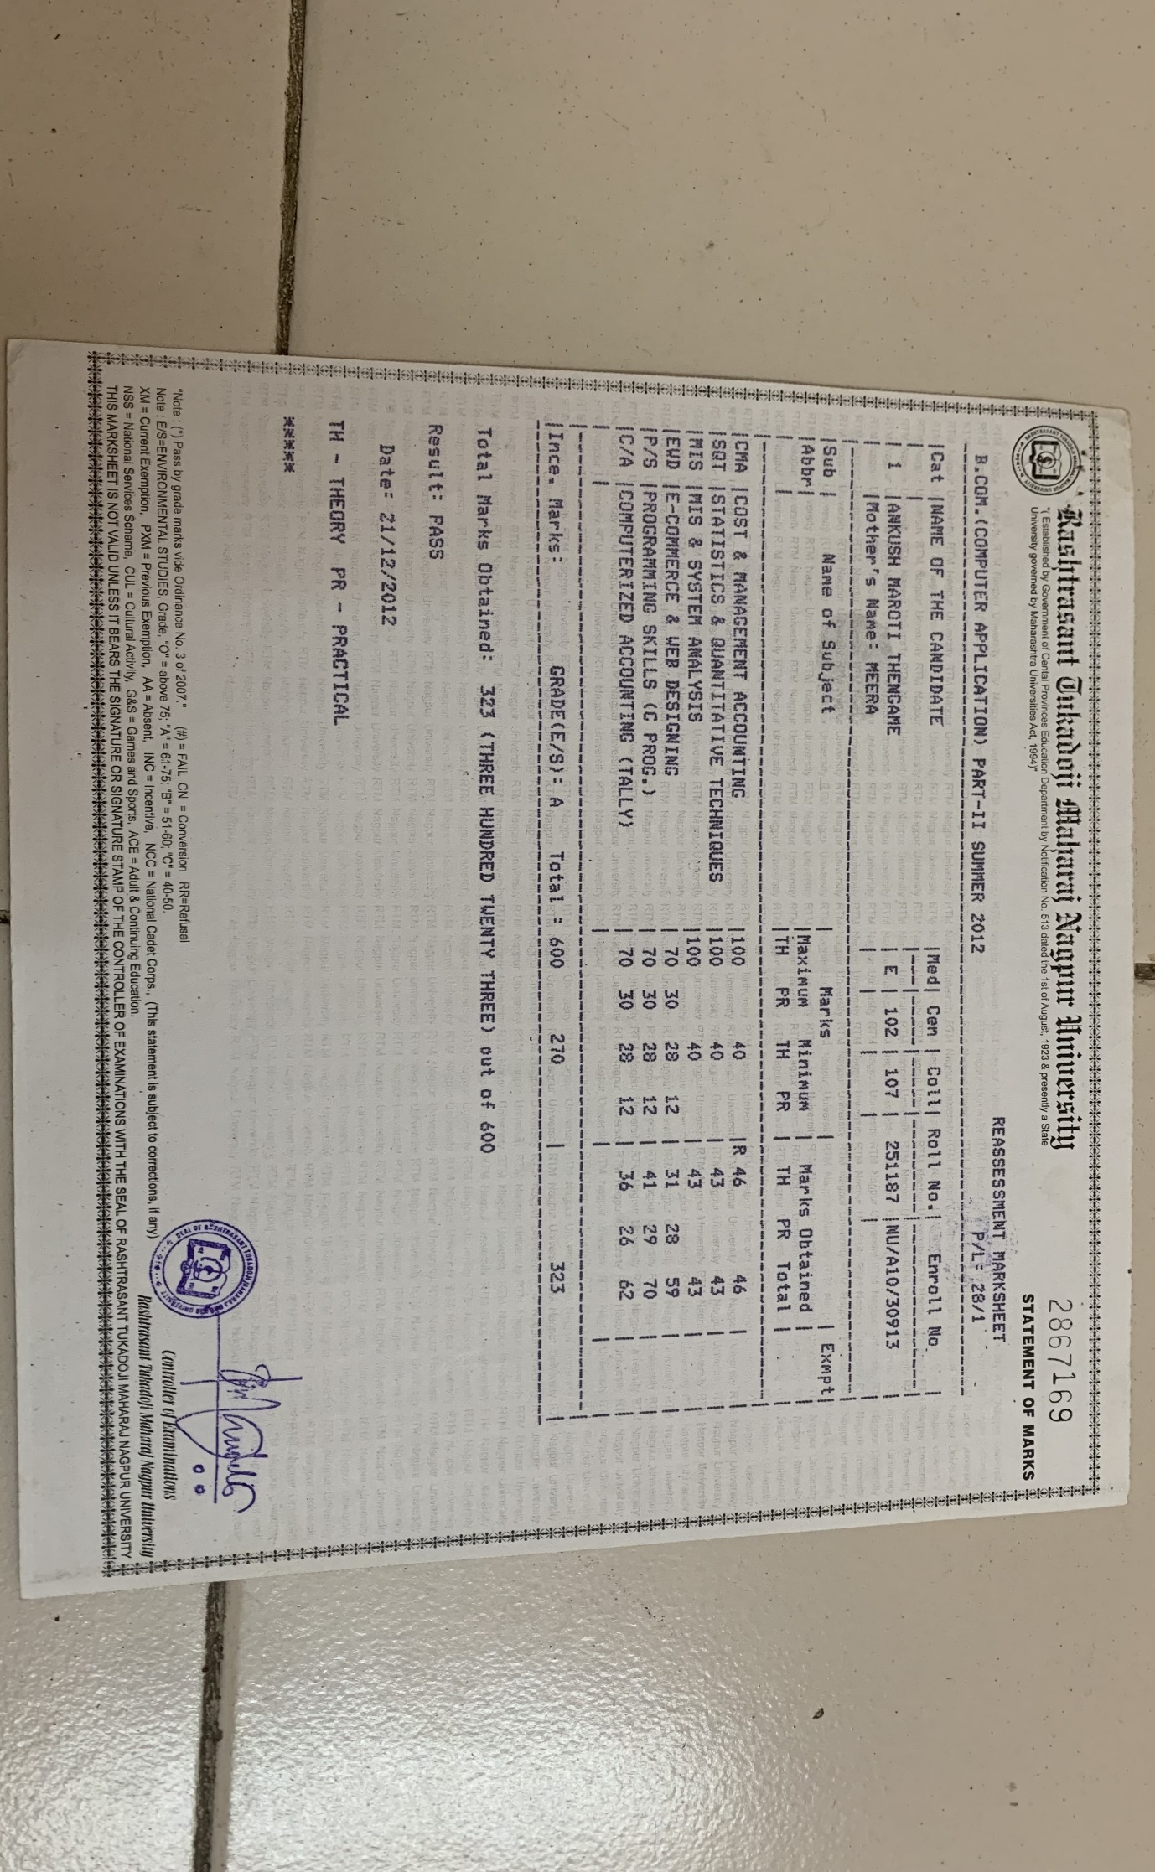

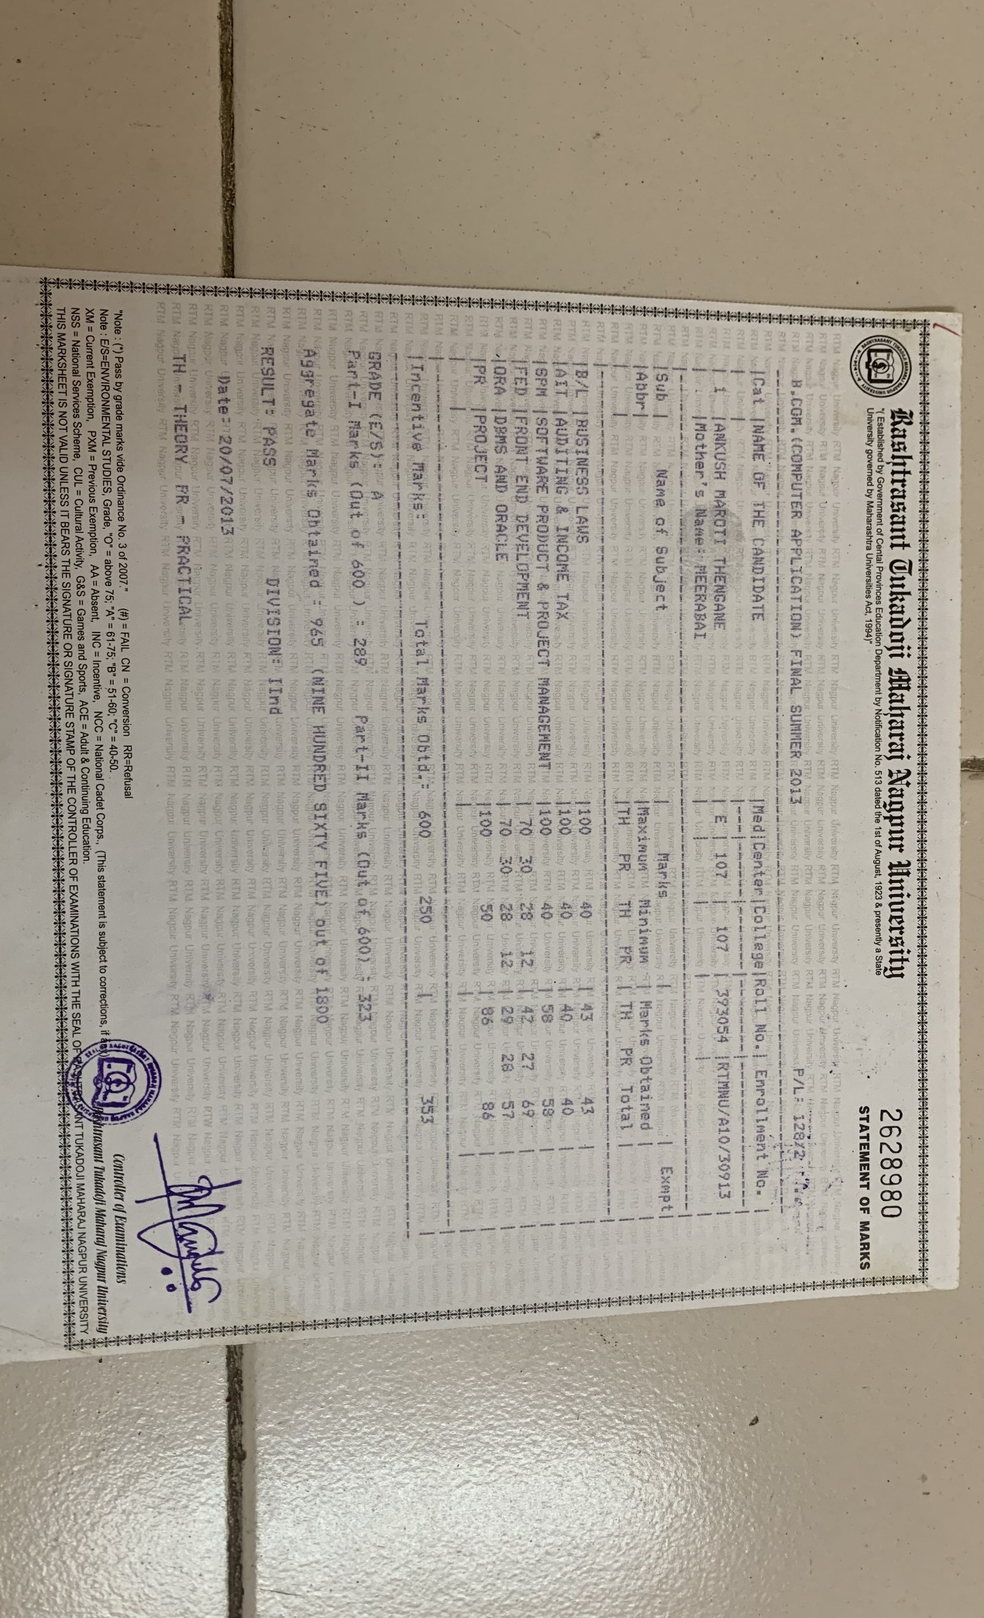

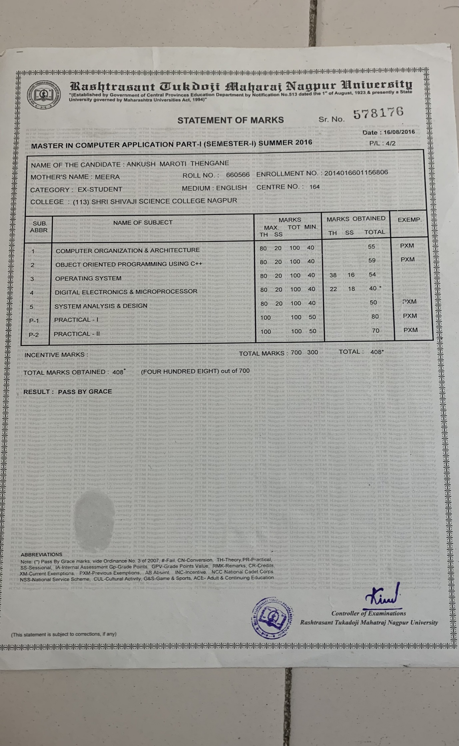

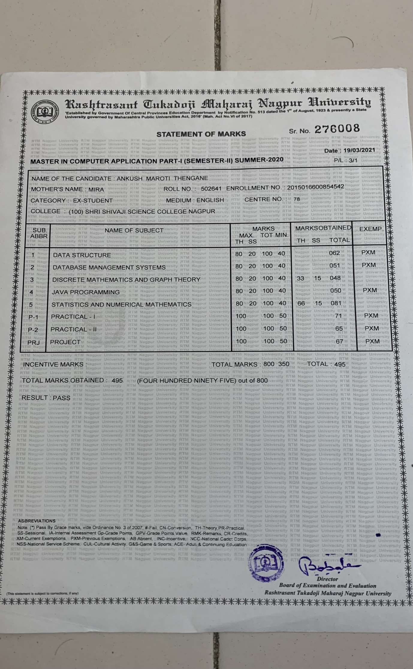

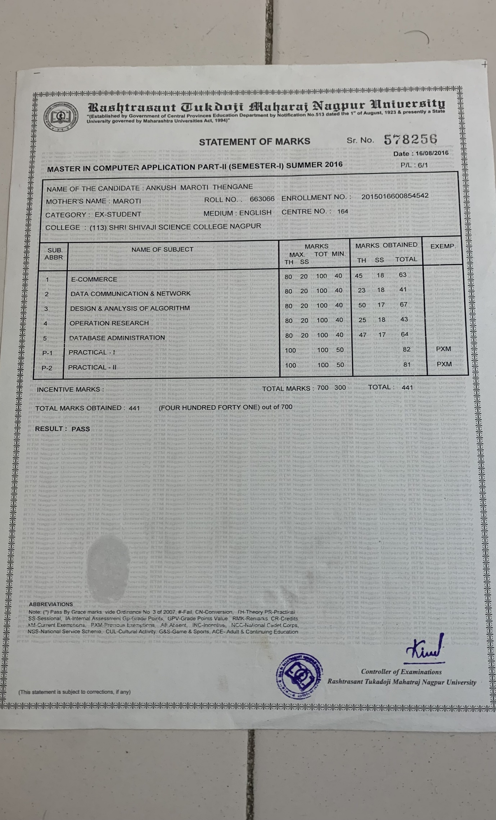

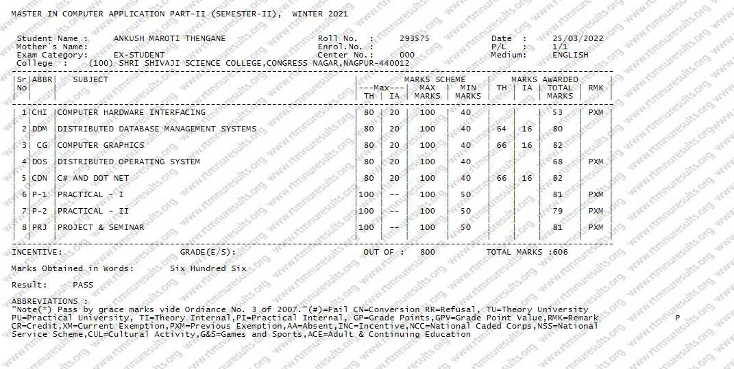

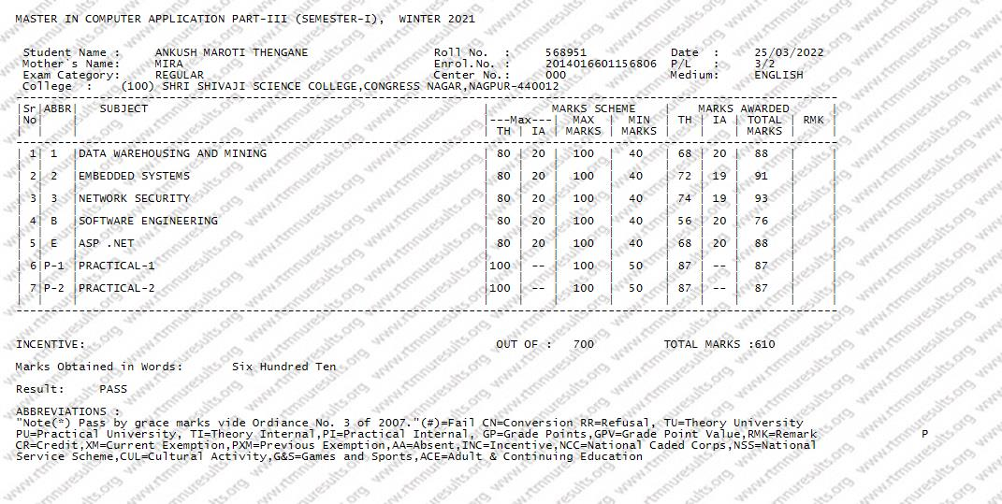

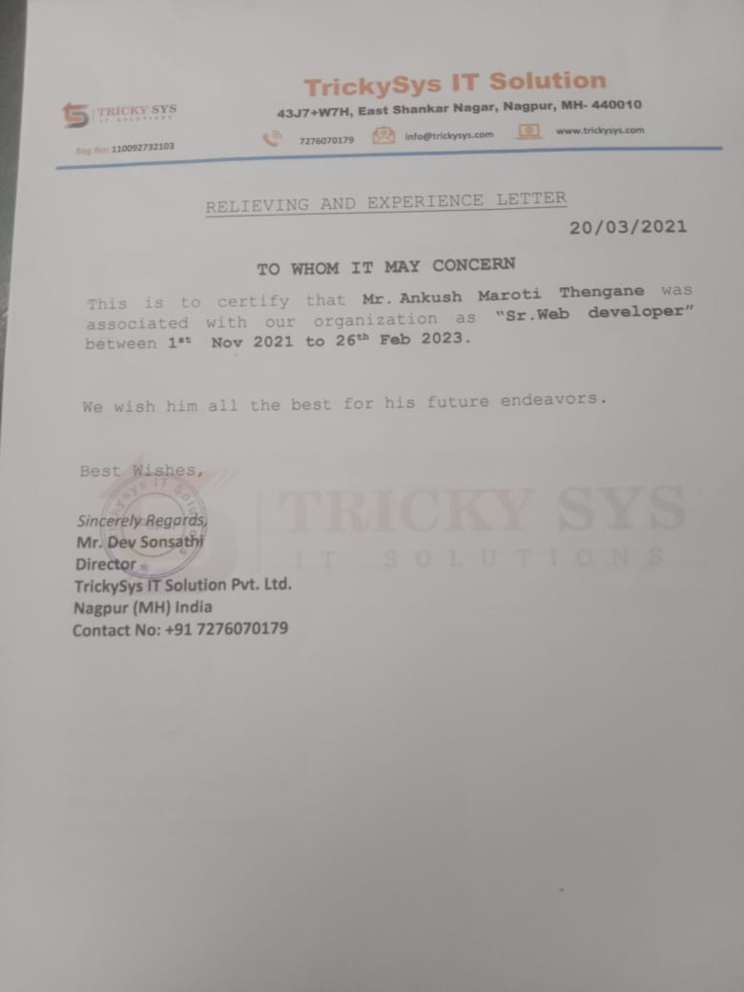

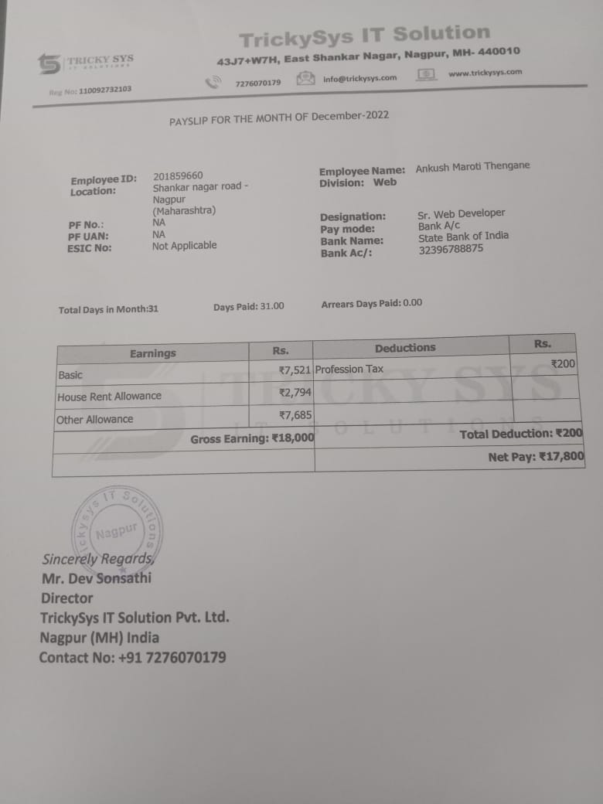

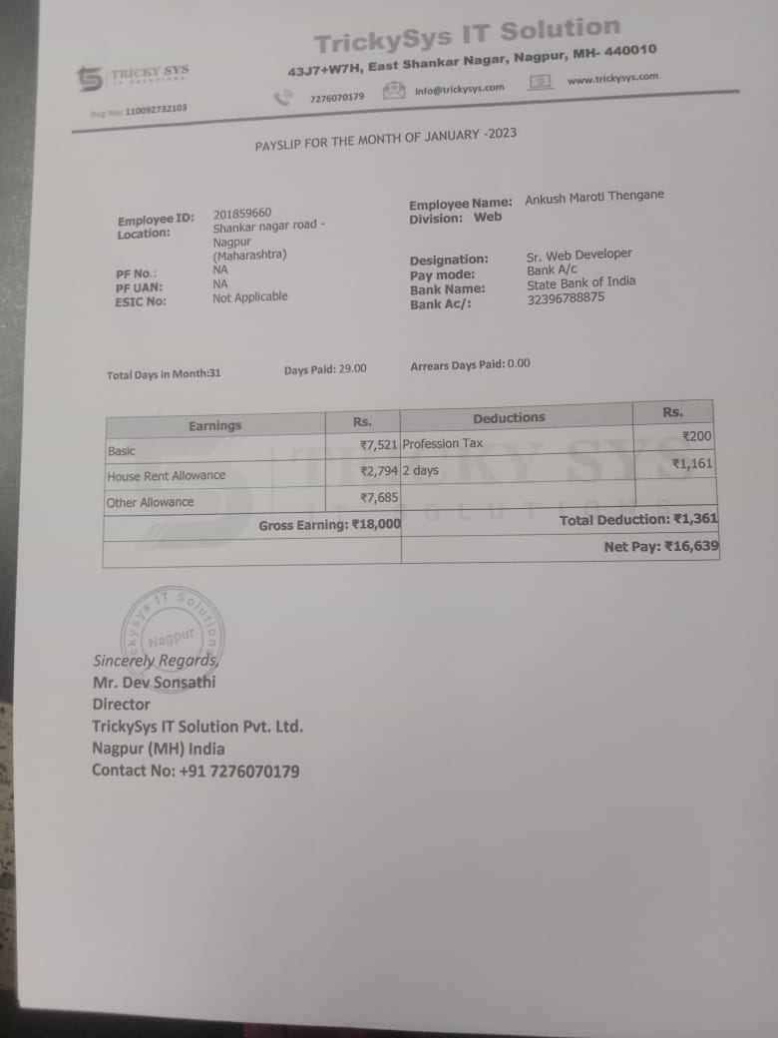

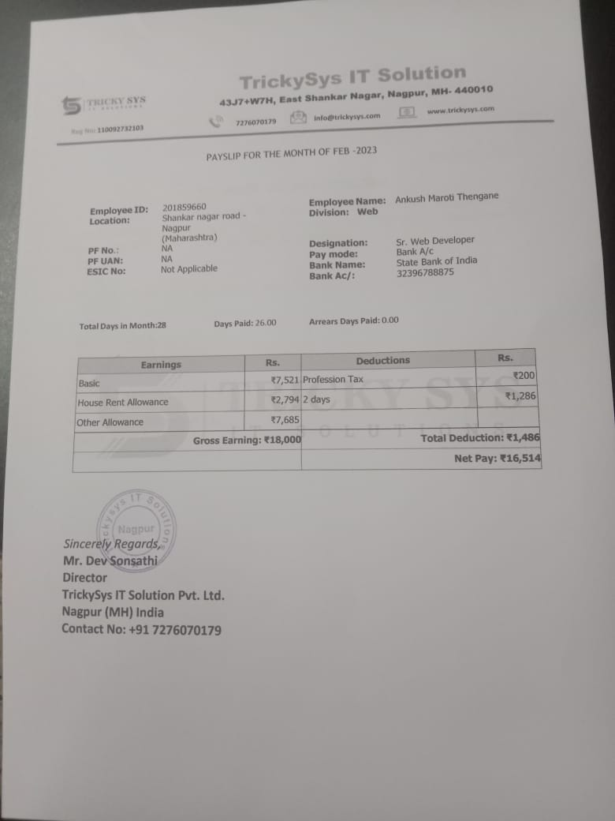

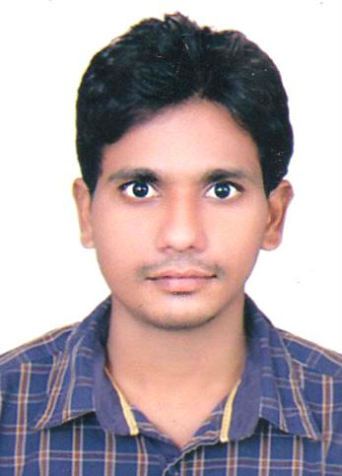

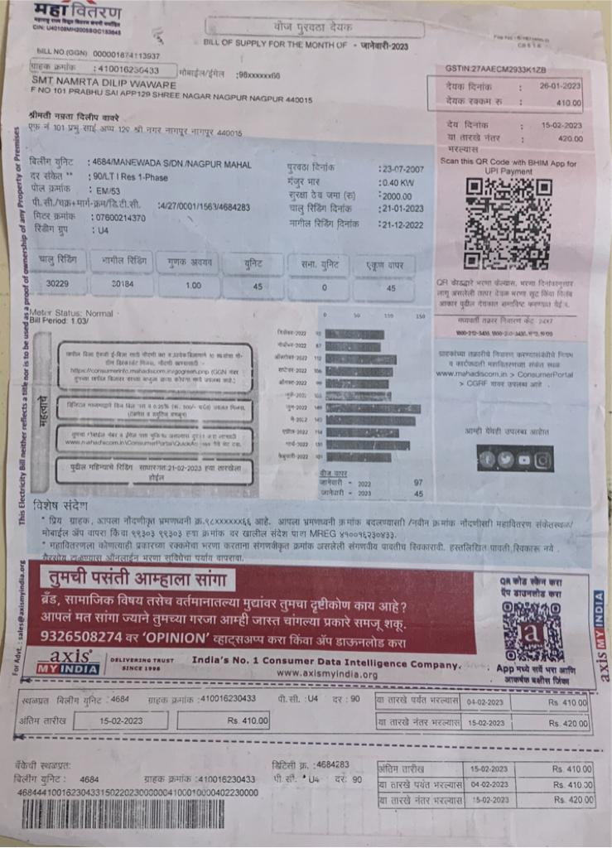

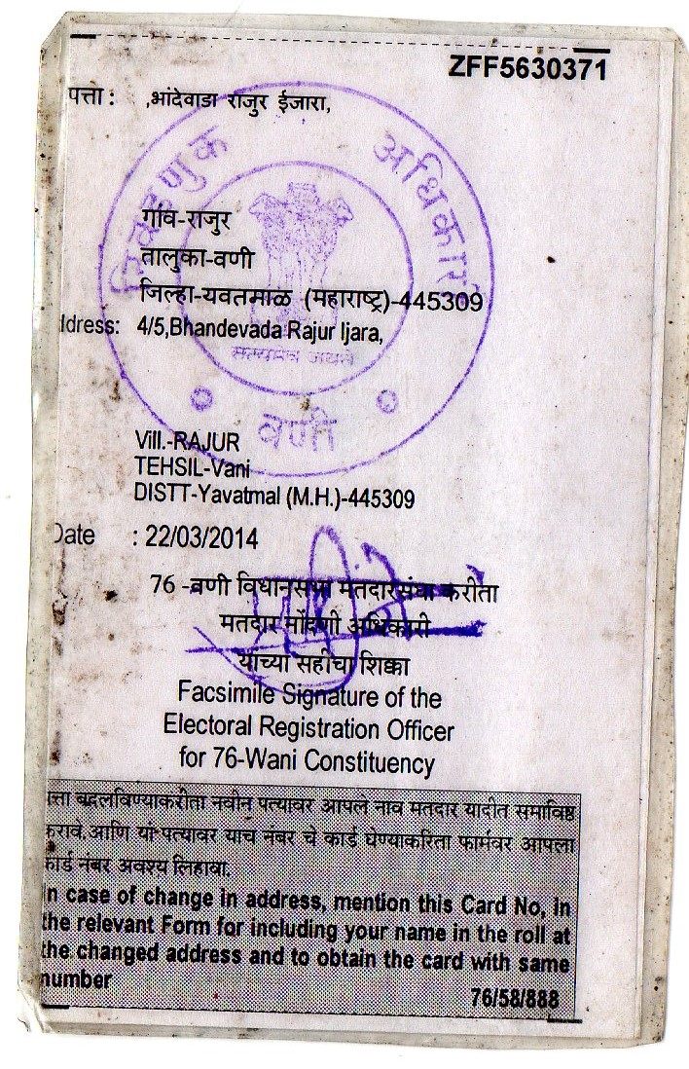

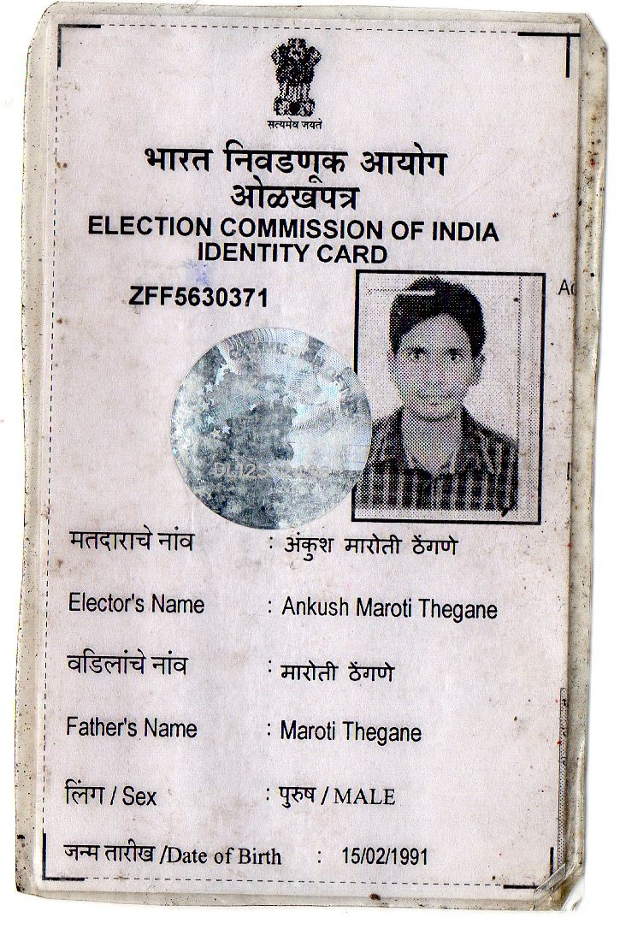

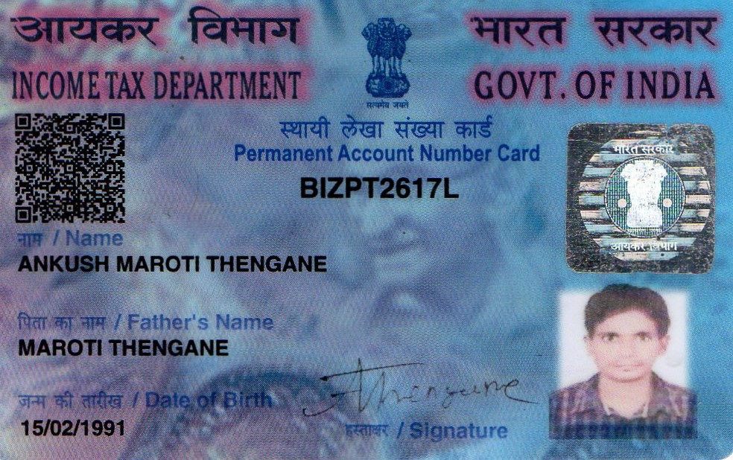



Account Name : Mr.ANKUSH MAROTI THENGANE

Account Number : 32396788875

Account Description : REGULAR

Branch : SAI MANDIR CHOWK, WANI

CIF No. : 86363937972

IFS Code : SBIN0014691

MICR Code : 445002303

# ANKUSH MAROTI THENGANE

Mobile No: **9850111244**

E-mail ID : [**ankthengane@gmail.com**](mailto:ankthengane@gmail.com)

**CAREER OBJECTIVE**

Looking for Job in an organization to utilize my skills and enhance my horizons as well As to contribute the best of my potential.

**SUMMARY**

* I have 1.6 years of professional experience in Web development using PHP, Angular, HTML5 and JavaScript Technologies.
* Proficient in handling diversified End-to-End Web Applications development projects individually as well as a team member.
* Good exposure in integrating APIs, Google Map, Social Media and Payment Gateway in Web Applications and website.
* Being involved in full life cycle projects, has imparted in me a very good understanding towards processes and plans to provide effective solutions to challenging business requirements.
* Adept in database technologies like MySQL.
* Knowledge of web frameworks like Angular,Codeigniter 3.
* Knowledge in developing RESTful APIs using Codeigniter frameworks.
* Possess good communication and inter-personal skills.

**WORK EXPEIRENCE**

* Working as Web Developer with **TRICKYSYS IT Solutions Pvt Ltd (from November, 2021 to till now).**

**PROJECT PROFILE**

**Project 1 :**

Title : **Food Grain Distribution Management System**

Team Size 3

Technology : Codeigniter 3,Angular 8, HTML5, Bootstrap 2, MySQL, Ajax, JQuery Description : This application is mainly used for management and tracking all the Food Distribution. One tag is assigned to the respective person and his movement is monitored and Track gets marked with this application.

# Project 2 :

Title : **E - Police**

Team Size 4

Technology : Codeigniter 3, Angular 8, HTML5, Bootstrap 2, MySQL, Ajax, JQuery Description : This application brings some different features in dealing with different sections for our city police. In this application, we can track movements done by the police personnel in an user friendly way. Here the crime data is noted just by filling all the necessary fields.

The main features come out to be:

1. B-Patrak
2. Camera Eye
3. Patrolling

Which is the fastest and quickest response for city police.

**SKILL DETAILS**

* + Operating Systems : Windows,Linux
  + Web Technology : PHP, Angular 8
  + API : restAPI
  + Framework : Codeigniter 3
  + Code Editor : Sublime Text ,Visual Studio Code.
  + CSS 3, JavaScript, HTML 5, Bootstrap 3, Ajax, Json.
  + Database: MYSQL.

**EDUCATION DETAILS**

* + Master in Computer Application (MCA) from Nagpur University in Year 2022 with 1st Division
  + Bachelors of Commerce in Computer Application (BCCA) from Nagpur University in Year 2013 with 2nd Division.
  + HSC in Art from Maharashtra Board in Year 2009 with 2nd Division.
  + SSC from Maharashtra Board in Year 2007 with 2nd Division.

**PERSONAL INFORMATION**

Date of Birth : 15/02/1991

Address : Plot no. 3A, Padmavati Nagari Near By Jannat Hotel, Wani- 445304,

Dt. Yavatamal,St. Maharashtra

Language Known : English, Hindi, Marathi

Phone No : 9850111244

E-Mail ID : [ankthengane@gmail.com](mailto:ankthengane@gmail.com)